**Algorithm Project-1 Tasks**

1. Travel Map

As shown in Figure 1, we have an undirected graph with nodes and distance. The distance is integers between nodes. For example, the shortest distance of node A and node B is 5.

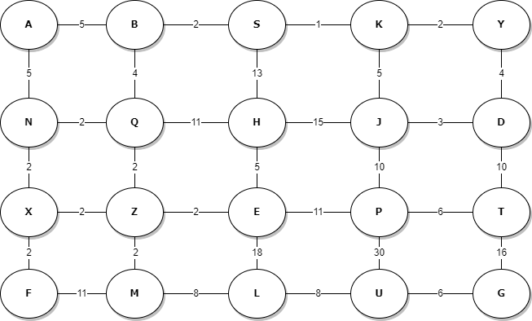

Figure 1- A road map: an undirected graph

1. Team Members

You may find your team members via four steps:

BrightSpace 🡪 Content 🡪 CX: Course Project

1. Project Algorithms

Graduates are expected to write Java program to implement the tasks below. For details, see the Table-1. In program codes, **students only choose Array, LinkedList, Priority Queue, or recursive functions to write codes**. Students SHOULD NOT choose hash table, dictionary, or other structures. If you violate the rules, your team will earn 0% points.

Table 1 – Subtasks of Project-1

|  |  |  |
| --- | --- | --- |
| Sub Tasks | Algorithms | Textbook |
| T-1 | DFS | Chapter 22: Elementary Graph Algorithm Algorithms  Page 594, Page 603 |
| T-2 | BFS |
| T-3 | Prim algorithm | Chapter 23: Minimum Spanning Trees  Page 631 |

1. Output Format

Table 2 – Output Format of Project-1

|  |  |  |  |
| --- | --- | --- | --- |
| Algorithms | Start Nodes | End Nodes | Output Format |
| DFS | Any nodes, especially  Nodes A, B, S, K, Y | Travel all nodes. | Display travel map with distances. For example, if your algorithms travel nodes A, B, S and K, your outputs  should be A (0), B (5), S (7), K (8).  Tips: If distance is the same, your algorithms should choose ascending sequence from node letters. |
| BFS | Any nodes, especially  Nodes A, Q, S, J, D |
| Prim algorithm | Any nodes | Travel all nodes. | Display travel map with distances, including total distances. |

1. Rubric

Table 3 – Grading Rubric

|  |  |  |
| --- | --- | --- |
| Tasks | Requirements | Points |
| Programs | Java codes with comments.  **only choose Array, LinkedList, Priority Queue, or recursive functions to write codes.** | 30% |
| Documents | 1)Choose writing format. For details, see the document named Project_Writing_Format.docx  2) Title, Team Contributors, Abstract, Introduction, Main context, Results, Discussion, Conclusion, Acknowledge, reference  Team leader submitted the project report, programming codes, PowerPoint slides by December 6th, 2022 at 11:59 pm CST | 20% |
| Presentation and demo | Living demo algorithms with PowerPoint slides  All team members must attend. Date: December 7th, 2022 | 50% |

1. Deadline and Submission

Deadline: The team leaders should submit the project report through BrightSpace by December 6th, 2022 at 11:59 pm CST. Some evaluation questions are expected.

Submission: Project report, programming codes, PowerPoint slides, etc.